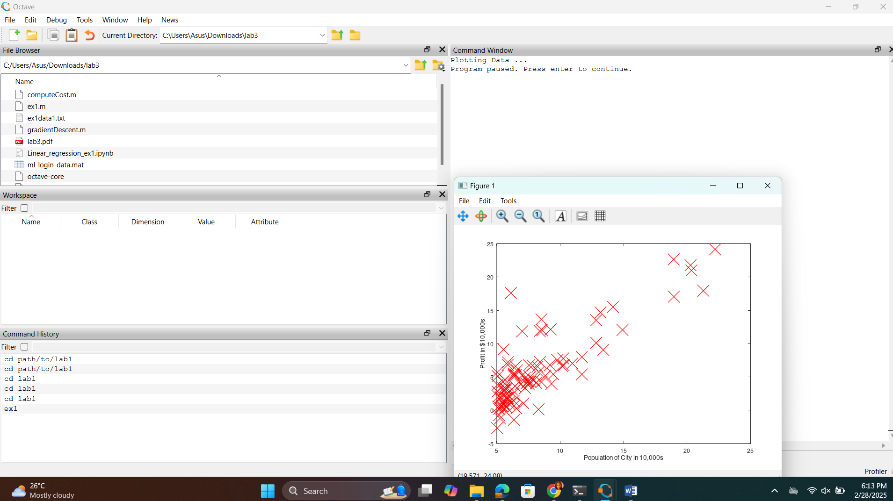

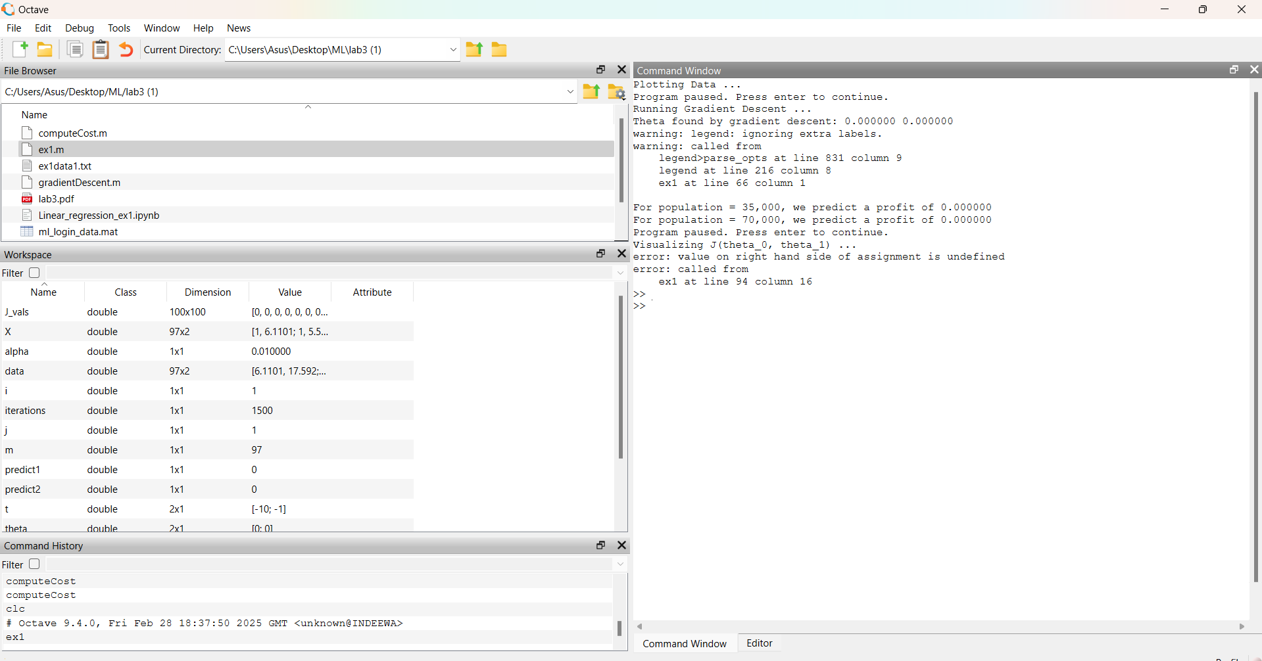

Plotting Data ...

Program paused. Press enter to continue.

Running Gradient Descent ...

Theta found by gradient descent: 0.000000 0.000000

warning: legend: ignoring extra labels.

warning: called from

legend>parse_opts at line 831 column 9

legend at line 216 column 8

ex1 at line 66 column 1

For population = 35,000, we predict a profit of 0.000000

For population = 70,000, we predict a profit of 0.000000

Program paused. Press enter to continue.

Visualizing J(theta_0, theta_1) ...

error: value on right hand side of assignment is undefined

error: called from

ex1 at line 94 column 16

>>

>>

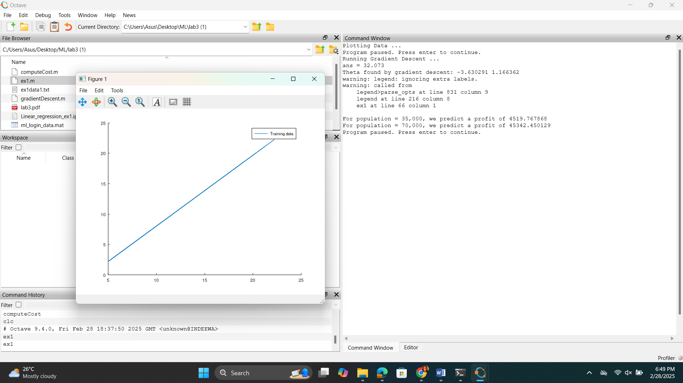

Plotting Data ...

Program paused. Press enter to continue.

Running Gradient Descent ...

ans = 32.073

Theta found by gradient descent: -3.630291 1.166362

warning: legend: ignoring extra labels.

warning: called from

legend>parse_opts at line 831 column 9

legend at line 216 column 8

ex1 at line 66 column 1

For population = 35,000, we predict a profit of 4519.767868

For population = 70,000, we predict a profit of 45342.450129

Program paused. Press enter to continue.

